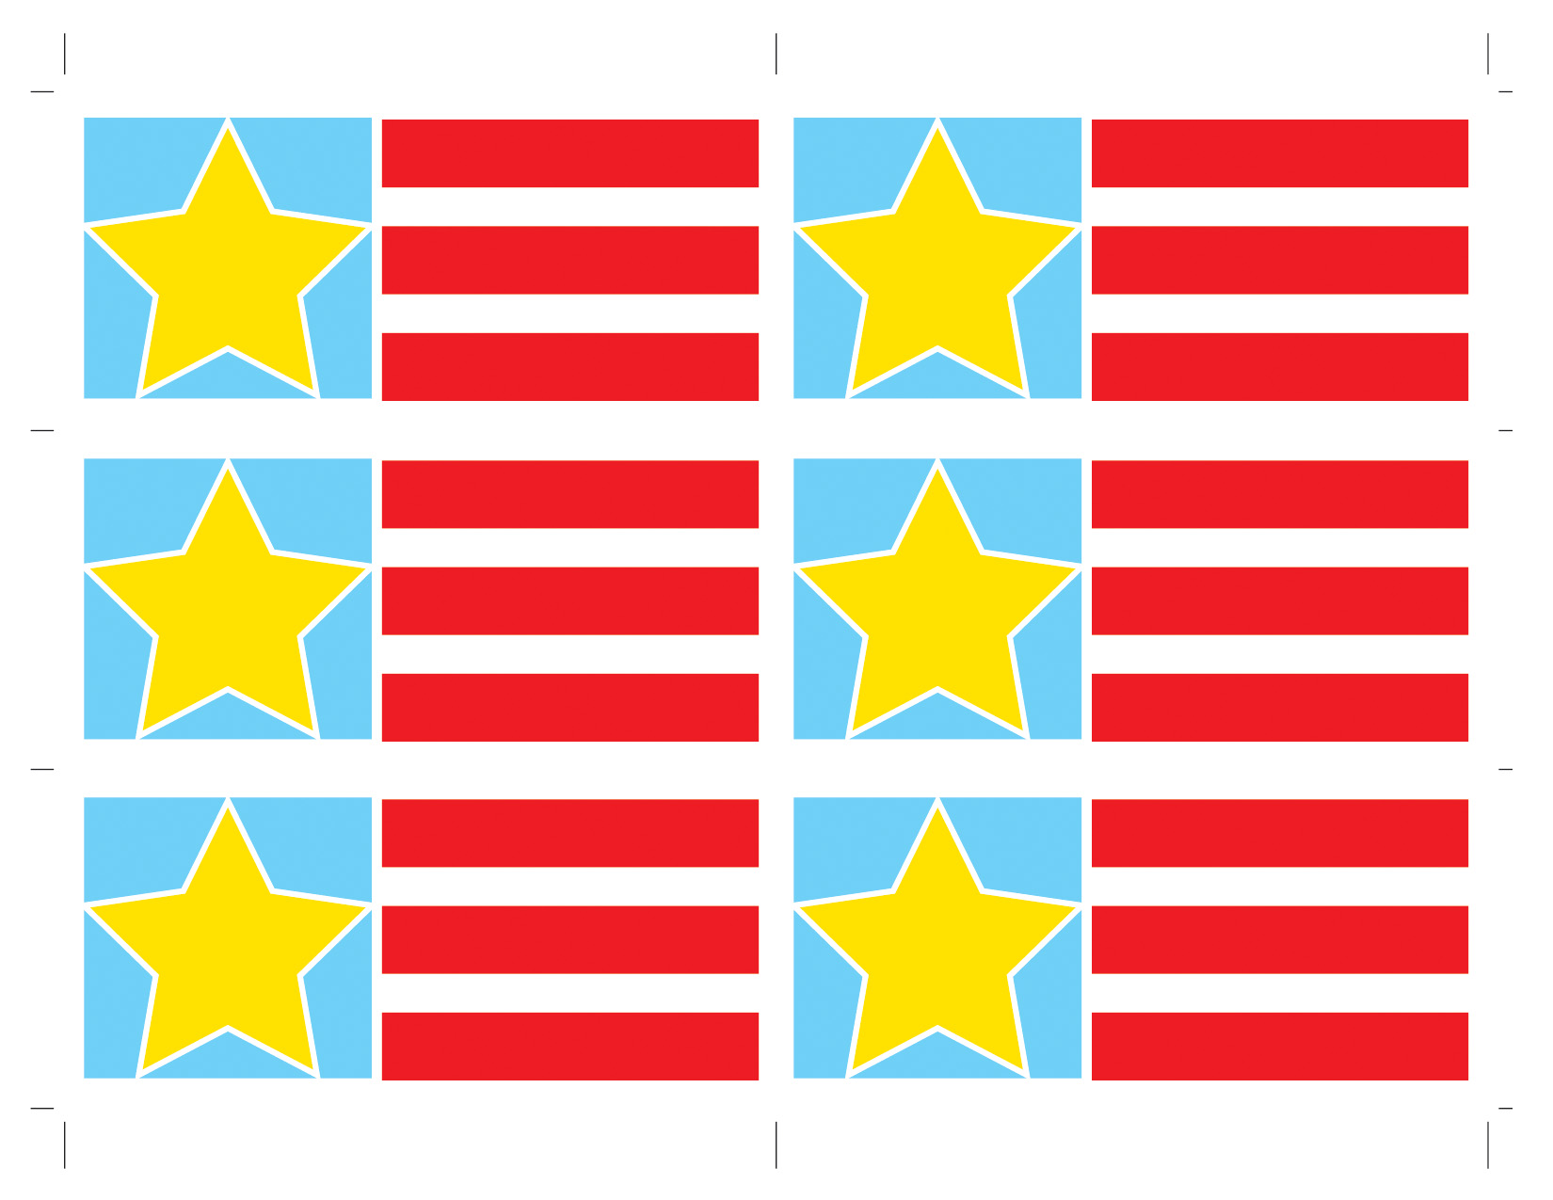

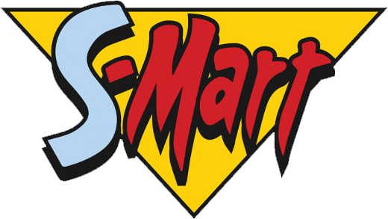











# **25% OFF First Online Order**

# **S-Mart**

# **June 5th**

**15% OFF Organic Chicken**

# **S-Mart**

# **June 4th**

# **15% OFF Grass Fed Beef**

# **S-Mart**

# **June 4th**

# **25% OFF S-Mart Products**

# **S-Mart**

# **Jun 3rd**

# **BYB Free 32 Pack Core**

# **S-Mart**

# **Jun 2nd**

# **25% OFF First Online Order**

# **S-Mart**

# **June 1st**